Patron: Colonel Steve Larkins OAM (Ret’d) President: Michael von Berg MC OAM

From the RARA-SA – Week Ending Friday 15th November, 2024

Fridays From 1600hrs to 2100hrs At 13 Beatty Street, Linden Park

[www.rarasa.org.au](http://www.rarasa.org.au) refers for all news and information

RARA-SA Facebook [www.facebook.com/groups/2069091733308307](http://www.facebook.com/groups/2069091733308307)

**This Friday 15th November, 2024**

1500hrs – Committee Meeting – Apologies please to Secretary Jim Stopford E: [jbstopford@bigpond.com](mailto:jbstopford@bigpond.com)

1600hrs - Traditional Evening Camaraderie over Evening drinks, in addition to tea and coffee being available, bar snacks

from 1700hrs with thanks to WO2 Caterer Colin Abel

1800hrs - The *Stand Fast* incorporating thereciting of *“the Ode”*, sounding of the *Last Post* and *Rouse* and including the

*Traditional Refrains*.

**Remembrance Day See the source image- 11th Hour Of The 11th Day Of The 11th  Month**

RARA-SA (Burnside) RSL – 2024 Remembrance Day See the source imageService - Regis Aged Care, Linden Park

RARA-SA (Burnside) RSL Members at this year’s Remembrance Day Service

L to R – Gino Arendic / Mal Allen / Peter Traynor / Secretary Greg “Spike” Dwiar / Lou Khorasanee

with Tina Yeow - Regis Aged Care / Singer Carolyn Minney / Pipe Major Andrew Fuller - City of Adelaide Pipe Band.

The residents including two WW11 Centenarian Veterans, very much appreciated the Service with sincere thanks to all

the above, in addition to Tim Freedman of Alpro Communications for the sound equipment.

**RARA-SA AGM 24th October, 2024 - Report by Secretary Jim Stopford**

In President Michael von Berg's MC OAM absence, Vice President Mr Rod Graham, presented the President's Annual Report. Additionally, Rod briefed the meeting on the health of Michael as he had been hospitalised after a blackout while attending the 7 RAR Parade, however all is now well and Michael is again back in the saddle. General discussions revolved around the future directions of RARA-SA and the RARA-SA (Burnside) RSL including the possible refurbishment of the Kensington Park RSL. This being identified as a fallback position for our membership if required, albeit we will not be vacating our current premises in the near future. Various aspects of the RAR-SA's survival into the future were discussed, and it was emphasised that these are very early discussions at the Committee level. However, the President and the elected committee members identified a necessity to share current committee discussions on these matters with the general membership. All in all a successful and convivial AGM with many points of view being put forward.

**Remembrance** See the source image**Day: Vietnam Veteran Private Richard Leslie Norden 1 RAR**

**awarded posthumous Victoria Cross**

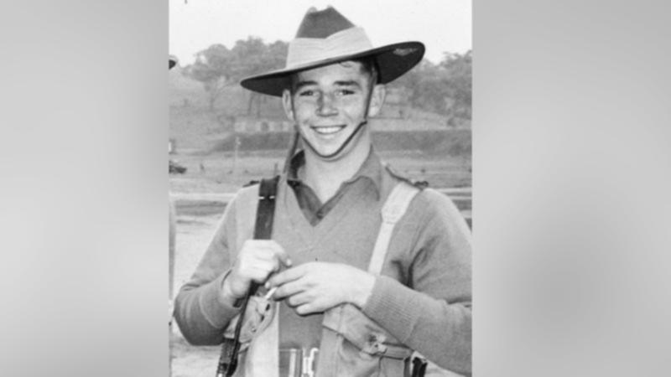

A young Australian private who ran back into enemy fire during the Vietnam War to rescue a wounded comrade and retrieve another’s body, has been posthumously awarded Australia’s highest military honour, the Victoria Cross for Australia. Richard Leslie Norden, recognised for “conspicuous acts of gallantry”, becomes the 102nd Australian to receive

the honour of either the Victoria Cross or the Victoria Cross for Australia.

Governor-General Her Excellency Ms Sam Mostyn AC and Prime Minister The Honourable Anthony Albanese MP made the announcement after the national Remembrance Day See the source imageservice in Canberra, after being approved by His Majesty the King. This follows years of campaigning and comes more than two years after the Defence Honours and Awards

Appeals Tribunal recommended Private Norden be awarded the Victoria Cross for Australia.

The medal recognises Private Norden’s acts on 14th May, 1968 during the Battle of Fire Support Base Coral near Saigon - one of the costliest for Australian troops during the war. Private Norden, then aged 19, ran into enemy fire after his platoon was ambushed during the battle to recover his wounded section commander and retrieve the body of his scout.

In announcing the honour, Her Excellency Ms Mostyn cited Private Norden’s “courage and selflessness in the heat of

battle, his ongoing legacy and the bravery of generations of our service personnel.

“This is an historic occasion for Australia and the Australian Defence Force, and a very significant day for Private

Norden’s loved ones.”

Private Norden died in 1972 from injuries he sustained in a motorcycle incident while serving in ACT Police. He had been awarded a Distinguished Conduct Medal before his death and there had been an active campaign for him to receive

Australia’s highest military honour.

Prime Minister Anthony Albanese paid tribute to all those who had “championed and advocated” for the Victoria Cross in

his address.

“In honouring Richard Norton and all he fought for, Australia also honours all those who fought for him: his fellow veterans, those who served alongside him, and those who took up his cause when they learned of his story,” Mr

Albanese said.

“This is a man who went forward again and again, despite being wounded, to rescue his section commander who he carried and dragged back to safety,” he said. “Then he went forward and fought off (the enemy) ... he went back to get more hand grenades and then went forward again to secure the areas, so the body of his scout could be recovered. “All the while he’s had been wounded. Almost certainly every time he went forward, he must have thought ‘this is it’, but he went forward again and again. It was truly a remarkable act of bravery.”

***“Lest We Forget”***

Above Left: Privates Tristian Hudson and Brae Hopkins at the North Adelaide Shopping Village, North Adelaide

Above Right: Ptes Amberley Jude and Sam Pedrazzini at the Walkerville Shopping Centre, Walkerville

**RARA-SA (Burnside) RSL Annual Poppy See the source imageAppeal**

Sincere thanks to 7 RAR’s CO Lt Colonel Levon ‘von’ Lambert, 2IC Major Rupert Hindle, RSM WO1 Al Ashman and all ranks in addition to RARA-SA (Burnside) RSL members, Peter Traynor, Lyn and Robert Dow and the Walkerville Shopping Centre and North Adelaide Shopping Village Centre’s management and owners. This Appeal concluded 7 RAR’s very welcome assistance and support since 2011 for our ANZAC Rosemary , Legacy [Legacy](https://urldefense.proofpoint.com/v2/url?u=http-3A__www.legacy.com.au_&d=DwMFAg&c=8KPF0bmfmkzTkgg5U6HWH6_UmzF06L2ZWAVixC1qC44&r=kqePZrcFy9kadyaPFRkbWE9KCD14JYRcqH6SspB7jUw&m=sBx0bPRU5C3FXyKubZMcSlPXMDqETNL1k_sk5RQ4tTE&s=pgFgo5c2TmcyNWor5iU5UqJuZZLlz37BG790xsKn6m0&e=) and Remembrance Poppy [](https://urldefense.proofpoint.com/v2/url?u=https-3A__www.bing.com_images_search-3Fview-3DdetailV2-26ccid-3D6wrourF7-26id-3DC9EDA99BD3B7F1EDA90AEFF7A19907A6439A973C-26thid-3DOIP.6wrourF7dXEUxsqXBJaQTAEsDK-26q-3Dpoppy-2Bimages-2Bfree-26simid-3D608055126152449145-26selectedIndex-3D157&d=DwMFAg&c=8KPF0bmfmkzTkgg5U6HWH6_UmzF06L2ZWAVixC1qC44&r=kqePZrcFy9kadyaPFRkbWE9KCD14JYRcqH6SspB7jUw&m=sBx0bPRU5C3FXyKubZMcSlPXMDqETNL1k_sk5RQ4tTE&s=Z4kMTDzGKG4opLOJcWGVSHqRZk5hmXUnyzUxUs3E-3c&e=)Appeals during this period, enabling us to be one of the leading RSL Sub Branches in the collections. A great

effort by all involved.

Below Left: Private Lewis Llyod and Corporal J Halse at the North Adelaide Shopping Village

Below Right: Privates Aiden Gaddes and Sarim Chan at the Walkerville Shopping Centre North Adelaide

**On This Day**

11th November, 1941 - The opening of the Australian War Memorial in Canberra

14th November,1917 - End of third battle of Ypres, Western Front WW1- Australian troops had been involved in the third battle of Ypres for three and a half months and suffered heavy losses at such places as Menin Road, Glencorse Wood, Polygon Wood, Broodseinde Ridge and Passchendaele.

The RARA-SA is a strong supporter of the **Virtual War Memorial** and recommends that all who have active service and

peacekeeping service record their service at [www.vwma.org.au](http://www.vwma.org.au)

RARA-SA See the source image Club Manager / RARA-SA (Burnside) RSL Image result for rsl logos Sub Branch Secretary M: 0412 644 749 / E: [rar01@internode.on.net](mailto:rar01@internode.on.net) / W:  [www.rarasa.org.au](http://www.rarasa.org.au) / Facebook [www.facebook.com/groups/2069091733308307](http://www.facebook.com/groups/2069091733308307)

**Proudly Supported By Bolton Clarke** Image result for bolton clarke logoImage result for bolton clarke logoImage result for bolton clarke logo **Australia’s Largest Independent Private Aged Care Provider**