Patron: Colonel Steve Larkins OAM (Ret’d) President: Michael von Berg MC OAM

From the RARA-SA – Week Ending Friday 18th October, 2024

Fridays From 1600hrs to 2100hrs At 13 Beatty Street, Linden Park

[www.rarasa.org.au](http://www.rarasa.org.au) refers for all news and information

RARA-SA Facebook [www.facebook.com/groups/2069091733308307](http://www.facebook.com/groups/2069091733308307)

**This Friday 25th October, 2024**

1600hrs - Traditional Evening Camaraderie over Evening drinks, in addition to tea and coffee being available, Light

refreshments as detailed below.

1800hrs - The *Stand Fast* incorporating thereciting of *“the Ode”*, sounding of the *Last Post* and *Rouse* and including the

*Traditional Refrains*.

|  |
| --- |
|  |

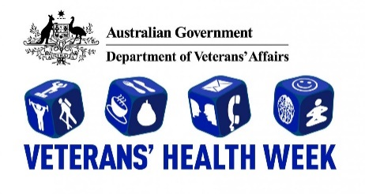

Commencing at 1730hrs leading up to the *Stand Fast* (including the reciting of *the Ode* and *Traditional Refrains)*

The RARA-SA Veterans Health Week "Keeping Connected" theme will centre around a couple of small presentations, one by RAAF Squadron Leader Ash Wright and focusing on "effective and good communication". Ash was the former OC of Edinburgh Air Traffic Control in addition to RAAF Mobile Flight Commander at Victoria Park during last year’s Vailo 500

Car Race F-35A flyover.

 Our next speaker will be RSL-SA CEO Tara Bolten, Tara as CEO of RSL-SA will speak on the RSL SA Reach Out Wellbeing Program which has been established to provide its overall goal of guidance, support, and service advice in a

one-stop shop approach to Veterans and their families, statewide.

This will be followed by an informal gathering over snacks which will include Oysters, Prawns, Cold meats and salads,

with light refreshments provided. Full bar facilities will be available.

All our members are welcome, including wives and partners.

To assist with our catering a RSVP by Thursday 24th would be appreciated.

Greg 'Spike' Dwiar - RARA-SA Club Manager E: [rar01@internode.on.net](mailto:rar01@internode.on.net)

**This Saturday 26th October, 2024**

7 RAR Farewell Parade – Torrens Parade Ground, King William Road Adelaide -

Marching on at 1000hrs

Commanding Officer Lt Colonel Levon von Lambert extends an invitation for all to attend.

Neat casual address with medals as entitled is requested – the flyer on page 2 refers.

**This Sunday 27th October, 2024 – RARA-SA Annual General Meeting – 1100hrs**

Notice is given to all members that the 2024 RARA-SA AGM will be held at the RARA-SA 13 Beatty Street, Linden Park 1100hrs on Sunday 27th October commencing at 1100hrs. This will be followed by a Barbeque lunch.

Club Manager Greg “Spike” Dwiar has forwarded a revised AGM notice etc via separate email to all members

Apologies to Secretary Jim Stopford please – E: [jbstopford@bigpond.com](mailto:jbstopford@bigpond.com)

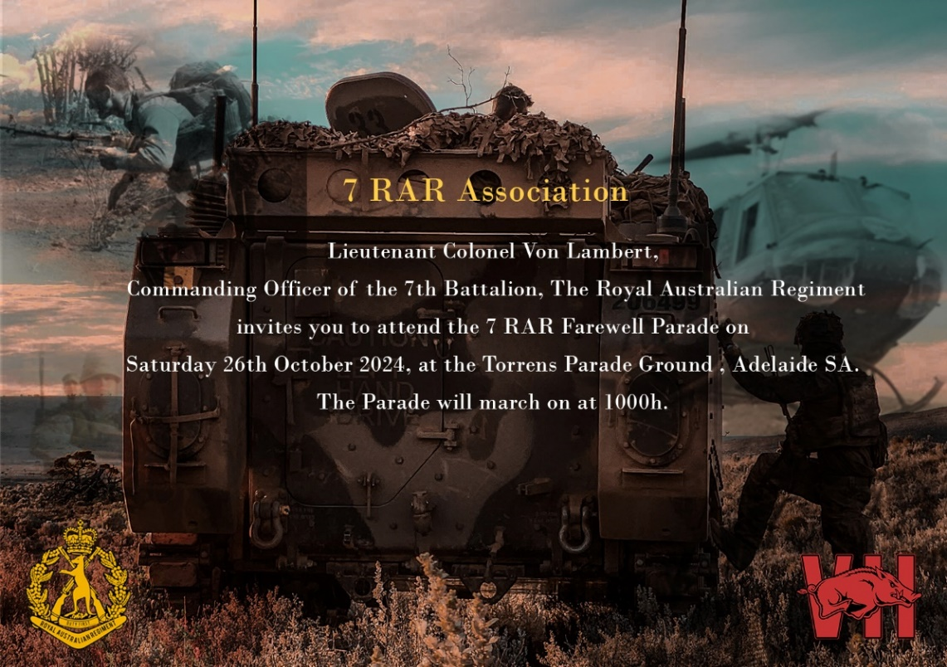

|  |  |
| --- | --- |
| |  | | --- | |  | |
| |  |  |  | | --- | --- | --- | | |  |  | | --- | --- | |  | **24 October, 2024**  Welcome to the latest edition of Army News.  Click [HERE](https://www.enudge.com.au/securl?nudge=y22983zpr3824987&link=144046&email=mal@aladdco.com.au) to read this edition.  **COMBINED ARMS:** Troops bring growl to Ex Southern Tiger – **Page 3**  **EX HARI’I HAMUTUK:** Building bonds in Timor-Leste – **Pages 5 and 7**  **FIRE AT WILL:** Soldiers practise tools of the trade on weapons course – **Pages 10-11**  To read the latest editions of Navy News and Air Force News click [HERE](https://www.enudge.com.au/securl?nudge=y22983zpr3824987&link=144047&email=mal@aladdco.com.au) | | |

**On This Day Courtesy of the AWM and RARA-SA Sources**

22nd October, 1950 – Korea – C Company, 3 RAR became involved in their first major action of the Korean War, the

Battle of the Apple Orchard, Yongju, Korea.

23rd October, 1942 – Egypt, WW11 - The battle of El Alamein, in Egypt, one of the turning point battles of the Second

World War, began with a massive artillery bombardment preceding attacks by British and Australian divisions.

29th October, 2011 - Afghanistan - Captain Bryce Duffy, 4th Regiment, Royal Australian Artillery, serving with MTF 3 was

shot and killed by a member of the Afghan National Army.

29th October, 2011 - Afghanistan – Corporal Ashley Birt, serving as a Geospatial Technician in the 6th Engineer

Support Regiment was shot and killed by a member of the Afghan National Army.

30th October, 1918 – An Armistice was signed with Turkey, ending Turkish involvement in WW1. Australian troops had

taken a prominent part in the war against the Ottoman empire, especially at Gallipoli and in the Sinai-Palestine.

The RARA-SA is a strong supporter of the **Virtual War Memorial** and recommends that all who have active service and

peacekeeping service record their service at [www.vwma.org.au](http://www.vwma.org.au)

RARA-SA See the source image Club Manager / RARA-SA (Burnside) RSL Image result for rsl logos Sub Branch Secretary M: 0412 644 749 / E: [rar01@internode.on.net](mailto:rar01@internode.on.net) / W:  [www.rarasa.org.au](http://www.rarasa.org.au) / Facebook [www.facebook.com/groups/2069091733308307](http://www.facebook.com/groups/2069091733308307)

**Proudly Supported By Bolton Clarke** Image result for bolton clarke logoImage result for bolton clarke logoImage result for bolton clarke logo **Australia’s Largest Independent Private Aged Care Provider**