Patron: Colonel Steve Larkins OAM (Ret’d) President: Michael von Berg MC OAM

From the RARA-SA – Week Ending Friday 1st November, 2024

Fridays From 1600hrs to 2100hrs At 13 Beatty Street, Linden Park

[www.rarasa.org.au](http://www.rarasa.org.au) refers for all news and information

RARA-SA Facebook [www.facebook.com/groups/2069091733308307](http://www.facebook.com/groups/2069091733308307)

**This Friday 1st November, 2024**

1600hrs - Traditional Evening Camaraderie over Evening drinks, in addition to tea and coffee being available, bar snacks

from 1700hrs with thanks to WO2 Caterer Colin Abel

1800hrs - The *Stand Fast* incorporating thereciting of *“the Ode”*, sounding of the *Last Post* and *Rouse* and including the

*Traditional Refrains*.

|  |
| --- |
|  |

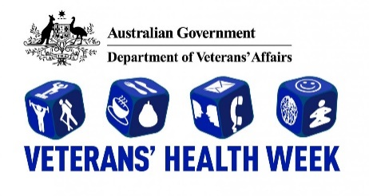

Left: Newly appointed RSL-SA’s CEO Tara Belton and Right RAAF’s Squadron Leader Ash Wright speaking at last Friday night’s very successful Veterans Health Week Symposium. The "Keeping Connected" theme focusing on "effective and good communication”. This was followed by an informal pleasant gathering over light refreshments with particular

thanks to WO2 Caterer Colin Abel and Club Manager Greg “Spike” Dwiar for all their hard yakka in the organisation.

Also our appreciation to all members, family and friends who attended, adding to the great evening.

Photographs courtesy of RARA-SA Member Joanne Murdock who also is our photographer for the RARA-SA’s (Burnside) RSL’s ANZAC Day Dawn Service at the Norwood War Memorial, Osmond Terrace, Norwood.

**Saturday 26th October, 2024**

7 RAR Farewell Parade – Torrens Parade Ground, King William Road, Adelaide

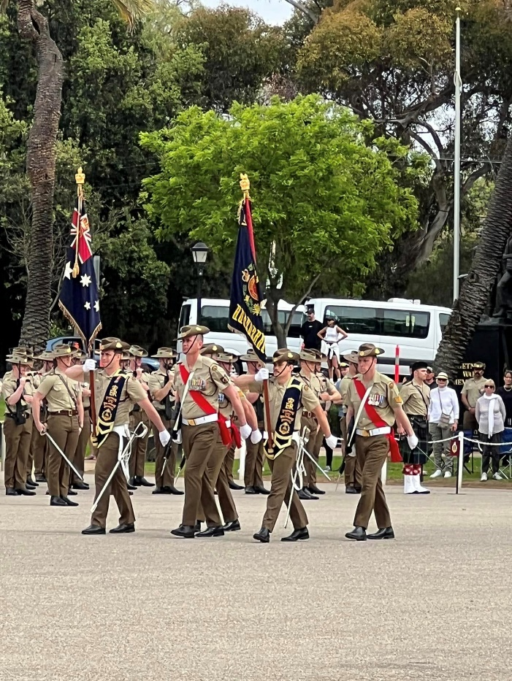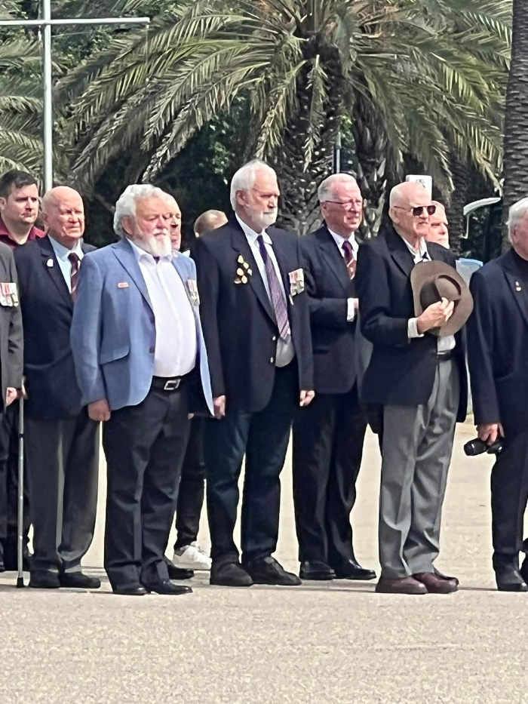

Above Left: The Battalion Colours being paraded / Right: The “Old and Bold” - 7 RAR Veterans

Below Left: Rachel Hopkins and former 7 RAR CO Lt Colonel Roland Spackman CSC at the Pathway of Honour

Below Right RARA-SA President Michael von Berg MC OAM and 7 RAR CO Lt Colonel Levon ‘von’ Lambert

(We are pleased to advise that Michael has recovered from a slight medical episode on Saturday at the Parade)

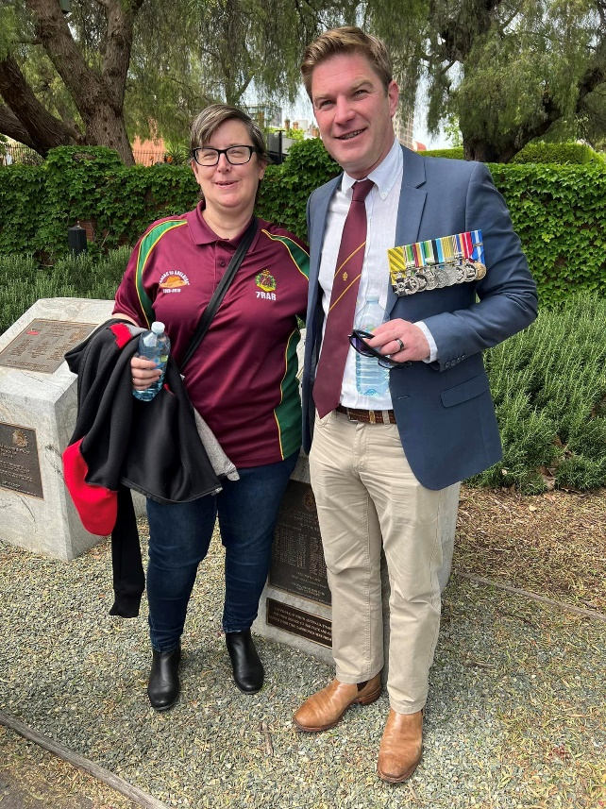

Photographs courtesy of RARA-SA Member Rachel Hopkins (whose late Father served with 7 RAR) and the RARA-SA

**Simpson Cup Challenge – Sunday 27th October, 2027**

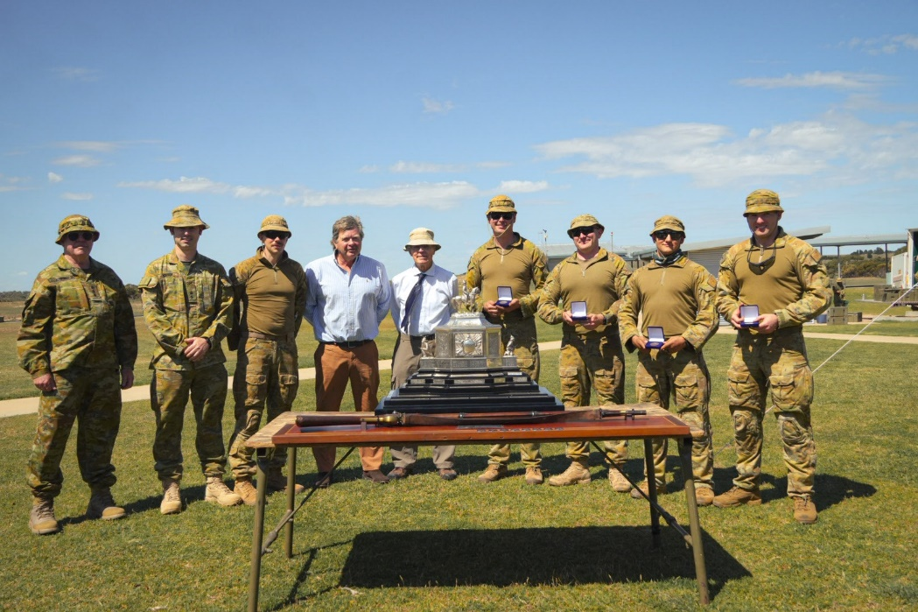

10/27 RSAR hosted the 2024 Simpson Trophy shoot, which is the oldest still-running shooting competition in the Southern hemisphere, and one of the oldest in the world. The first competition was held in 1890, sponsored by The Honourable Alfred Muller Simpson MLC, to help bolster South Australia's colonial defences. This year, eight teams competed. Six were from units across [9th Brigade - Australian Army](https://www.facebook.com/9BdeAusArmy?__cft__%5b0%5d=AZU_lRBPH2DgKvT4uWuxIgIjMmkSolsiSt-sGm97p4HlEP99djhKi2YeNnLT7uOLUmkzgDsbluhUys793U3DFXEiH5CGYbIq4U8-QKh9YONkjLCNJVvH62GZDSWmwqNKyxhXaiK0PEtJs2GXn17fwdO1xGaX5XBANw1CCYfayBNFjBradVRmogtPsr2z92gwxt5W34JViVzPqOtdaCLFNOq61WrGGAbwPMWK7hzZtCRIjQ&__tn__=-%5dK-y-R), and one each from [Adelaide Universities Regiment - Australian Army](https://www.facebook.com/ADLUniRegtAusArmy?__cft__%5b0%5d=AZU_lRBPH2DgKvT4uWuxIgIjMmkSolsiSt-sGm97p4HlEP99djhKi2YeNnLT7uOLUmkzgDsbluhUys793U3DFXEiH5CGYbIq4U8-QKh9YONkjLCNJVvH62GZDSWmwqNKyxhXaiK0PEtJs2GXn17fwdO1xGaX5XBANw1CCYfayBNFjBradVRmogtPsr2z92gwxt5W34JViVzPqOtdaCLFNOq61WrGGAbwPMWK7hzZtCRIjQ&__tn__=-%5dK-y-R) and HMAS Encounter. The winning team this year was the 10/27 RSAR team, consisting of LT Alessio, CPL Lewis, CPL Guglielmi, LCPL Knight and PTE McKenzie The winner of the Best Individual Shot prize was TPR Beelitz

of 3rd/9th Light Horse (South Australian Mounted Rifles), [1st Armoured Regiment - Australian Army](https://www.facebook.com/1ArmdRegt?__cft__%5b0%5d=AZU_lRBPH2DgKvT4uWuxIgIjMmkSolsiSt-sGm97p4HlEP99djhKi2YeNnLT7uOLUmkzgDsbluhUys793U3DFXEiH5CGYbIq4U8-QKh9YONkjLCNJVvH62GZDSWmwqNKyxhXaiK0PEtJs2GXn17fwdO1xGaX5XBANw1CCYfayBNFjBradVRmogtPsr2z92gwxt5W34JViVzPqOtdaCLFNOq61WrGGAbwPMWK7hzZtCRIjQ&__tn__=-%5dK-y-R).

**On This Day – 29th October, 2011**

Corporal Ashley Birt (R), Lance Corporal Luke Gavin (C) and Captain Bryce Duff (R) were killed in an incident sparked by an Afghan National Soldier turning a machine-gun on Australian soldiers tasked with training him, during a weekly parade inside a forward operating base at Shah Wali Kot, in Kandahar Province. Seven other Diggers and three local

interpreters were wounded in the treacherous attack.

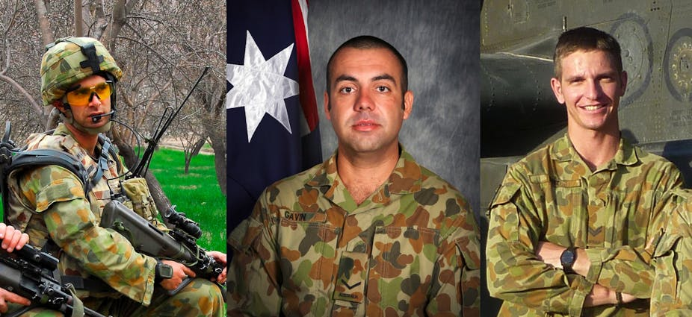

The RARA-SA is a strong supporter of the **Virtual War Memorial** and recommends that all who have active service and

peacekeeping service record their service at [www.vwma.org.au](http://www.vwma.org.au)

RARA-SA See the source image Club Manager / RARA-SA (Burnside) RSL Image result for rsl logos Sub Branch Secretary M: 0412 644 749 / E: [rar01@internode.on.net](mailto:rar01@internode.on.net) / W:  [www.rarasa.org.au](http://www.rarasa.org.au) / Facebook [www.facebook.com/groups/2069091733308307](http://www.facebook.com/groups/2069091733308307)

**Proudly Supported By Bolton Clarke** Image result for bolton clarke logoImage result for bolton clarke logoImage result for bolton clarke logo **Australia’s Largest Independent Private Aged Care Provider**