Patron: Colonel Steve Larkins OAM (Ret’d) President: Michael von Berg MC OAM

From the RARA-SA – Week Ending Friday 18th October, 2024

Fridays From 1600hrs to 2100hrs At 13 Beatty Street, Linden Park

[www.rarasa.org.au](http://www.rarasa.org.au) refers for all news and information

RARA-SA Facebook [www.facebook.com/groups/2069091733308307](http://www.facebook.com/groups/2069091733308307)

**This Friday 18th October, 2024**

1600hrs - Traditional Evening Camaraderie over Evening drinks, in addition to tea and coffee being available, bar snacks

from 1700hrs with thanks to WO2 Caterer Colin Abel

1800hrs - The *Stand Fast* incorporating thereciting of *“the Ode”*, sounding of the *Last Post* and *Rouse* and including the

*Traditional Refrains*.

|  |
| --- |
|  |

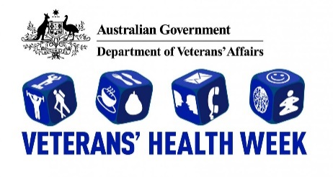

**Friday 25th October, 2024 at the RARA-SA**

Commencing at 1730hrs leading up to the *Stand Fast* (including the reciting of *the Ode* and *Traditional Refrains)*

The RARA-SA Veterans Health Week "Keeping the Spirit Alive" seminar will centre around a number of small seminars presented by Squadron Leader Ash Wright and RSL-SA CEO Tara Bolten, focusing on "effective and good communication". Ash was the former OC of Edinburgh Air Traffic Control in addition to RAAF Mobile Flight Commander at Victoria Park during last year’s Vailo 500 Car Race F-35A flyover. Tara as CEO of RSL-SA will speak on the RSL SA Reach Out Wellbeing Program which has been established to provide its overall goal of guidance, support, and service advice in a one-stop shop approach to Veterans and their families, statewide. This will be followed by an informal

gathering over snacks and light refreshments. All are welcome. Enquiries:

Greg “Spike” Dwiar M: 0412 644 749 / E: [gregdwiar@gmail.com](mailto:gregdwiar@gmail.com) or Mal Allen M: 0451 374 133 / E: [mal@aladdco.com.au](mailto:mal@aladdco.com.au)

**RARA-SA Annual General Meeting – 1100hrs - Sunday 27th October, 2024 – # Revised Date #**

Notice is given to all members that the 2024 RARA-SA AGM will be held at the RARA-SA 13 Beatty Street, Linden Park 1100hrs on Sunday 27th October commencing at 1100hrs. This will be followed by a Barbeque lunch.

Club Manager Greg “Spike” Dwiar has forwarded a revised AGM notice etc via separate email to all members

**RSL- Australia – Response to the Final Report of the Royal Commission into Defence and Veteran Suicide**

RSL National President Greg Melick has written to Prime Minister Anthony Albanese offering the expertise and resources of the League to assist the Government in developing its response to the Final Report of the Royal Commission into Defence and Veteran Suicide. He has asked for prompt acceptance and implementation of seven recommendations because early action on these will have a significantly positive impact on current and former serving men and women and their families. [**https://www.rslaustralia.org/s/News-Limited-Greg-Melick.png**](https://www.rslaustralia.org/s/News-Limited-Greg-Melick.png?fbclid=IwZXh0bgNhZW0CMTAAAR0AdDajZOrtu8RMp7-Jku9pSSy4Nc3JKwxv_Su7lpEiVz3nhsO8m_fv6lA_aem_ZdjsWCwYfI67JsFR32mo-w) refers.

**Rose Park Fallen Soldiers' Memorial – 100th Anniversary Commemoration – Saturday 14th December, 2024**

The Rose Park Fallen Soldiers' Memorial commemorates the brave sacrifice of those who served from the Burnside District. The 87 names listed on the Memorial honour the men who fell. Each name illustrates the tragedy of war.

The iconic statue, 'Helping Hand', sculpted by Australian artist C Web Gilbert was unveiled to much local fanfare in 1924.

The then Burnside RSL conducted the Annual ANZAC Day Dawn Service there until 2003 before being conducted by the Burnside/Prospect RAAF Association and now, a local group founded by Patron, Colonel Steve Larkins OAM (Ret’d).

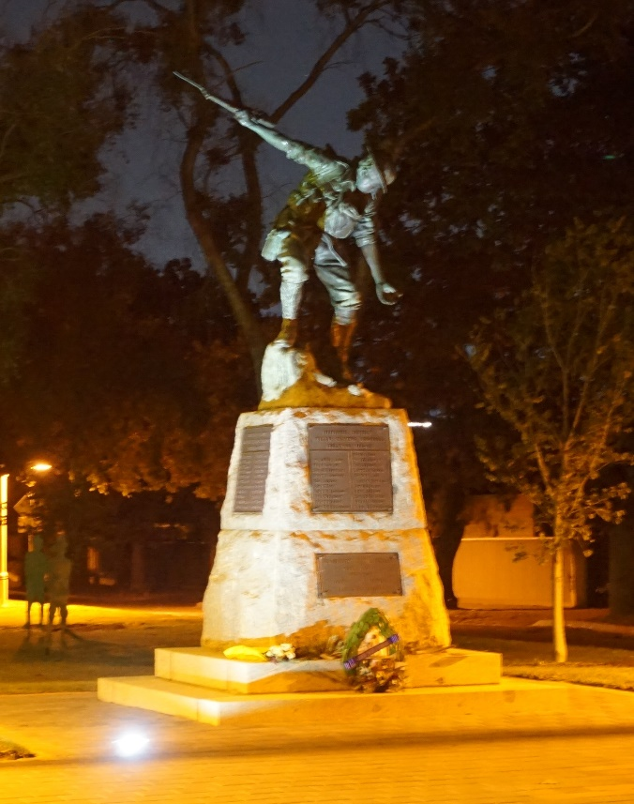

The above statue is on the corner of Alexandra Avenue and Prescott Tce, Rose Park where the 100th Anniversary ceremony will be held 1100hrs on Saturday 14th December, 2024 followed by light refreshments in the nearby Gartrell Church Hall. Enquiries: Colonel Steve Larkins OAM (Ret’d) E: [sandglarkins@outlook.com](mailto:sandglarkins@outlook.com) All are welcome to attend.

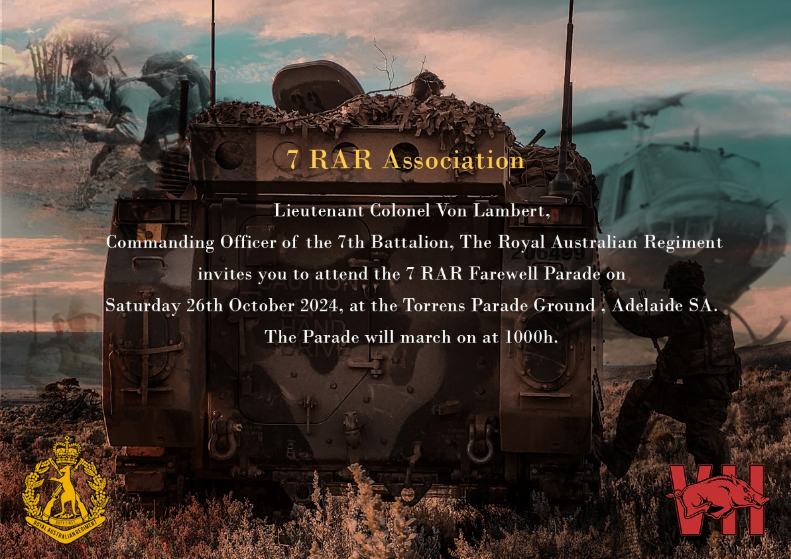

The RARA-SA is a strong supporter of the **Virtual War Memorial** and recommends that all who have active service and

peacekeeping service record their service at [www.vwma.org.au](http://www.vwma.org.au)

RARA-SA See the source image Club Manager / RARA-SA (Burnside) RSL Image result for rsl logos Sub Branch Secretary M: 0412 644 749 / E: [rar01@internode.on.net](mailto:rar01@internode.on.net) / W:  [www.rarasa.org.au](http://www.rarasa.org.au) / Facebook [www.facebook.com/groups/2069091733308307](http://www.facebook.com/groups/2069091733308307)

**Proudly Supported By Bolton Clarke** Image result for bolton clarke logoImage result for bolton clarke logoImage result for bolton clarke logo **Australia’s Largest Independent Private Aged Care Provider**