Patron: Colonel Steve Larkins OAM (Ret’d) President: Michael von Berg MC OAM

From the RARA-SA – Week Ending Friday 3rd May April, 2024

Fridays From 1600hrs to 2100hrs At 13 Beatty Street, Linden Park

[www.rarasa.org.au](http://www.rarasa.org.au) refers for all news and information

[Image result for rosemary images on anzac
                      day](https://urldefense.com/v3/__https:/www.bing.com/images/search?view=detailV2&ccid=qH1ankBY&id=9FEF2C1D6AE243334299123152D3DBD14A718CB5&thid=OIP.qH1ankBYGV83zQbWZn1v_wHaEG&mediaurl=http*3a*2f*2f1.bp.blogspot.com*2f-N7M1h7baDyg*2fT5ewxdWP-KI*2fAAAAAAAAAbE*2fLYgqyjVpaio*2fs1600*2fAnzac*2bDay*2bwith*2brosemary*2bfor*2bremembrance*255B1*255D.gif&exph=155&expw=280&q=rosemary*images*on*anzac*day&simid=608030305981366795&selectedIndex=0__;JSUlJSUlJSUlJSUlJSUlJSsrKys!!NFWRZ6kECLqu!-fz6s7CFuoBXTBWvZySlV8npYL8uw3sIbnWo14e2MBauKm28iVrIeKBYmRZAsG4voKN1$)

**Thursday 25th April, 2024**

**Traditional ANZAC Day flora - Wild Rosemary See
                  the source imagefrom the Clifftops of Gallipoli**

**Rosemary See
                  the source imagebeing the traditional emblem for Fidelity and Remembrance.**

**The wearing of a sprig of Rosemary See
                  the source imageon ANZAC Day acknowledges this.**

**RARA-SA (Burnside) RSL’s Norwood Dawn Service, Norwood War Memorial, Osmond Terrace, Norwood**

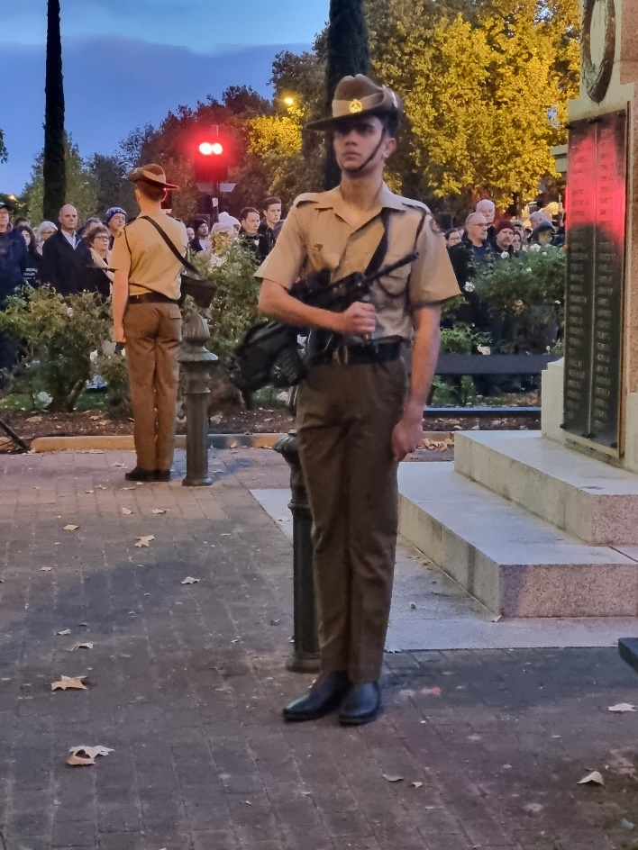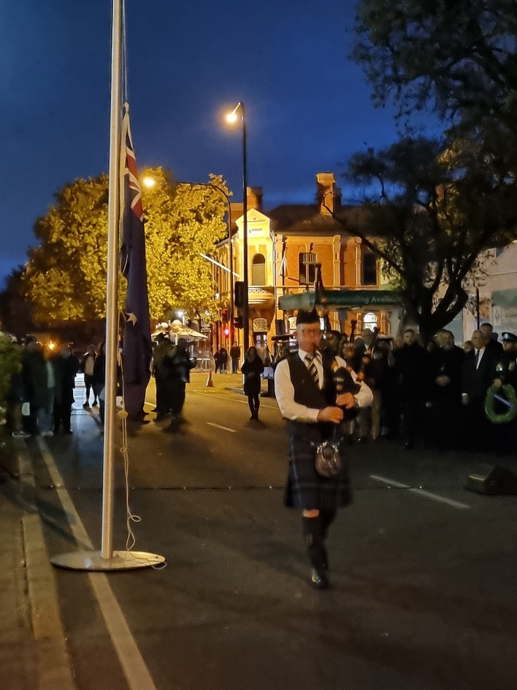

(Photographs courtesy of Ms Joanne Murdock)

Left: Members of 7RAR’s Catafalque Party under the command of Cpl Aaron Jackson having “Taken Post”.

Right: Piper Alistair McPhee from the City of Adelaide Pipe Band “Piping in the Dawn”

Sincere appreciation to all involved especially Lt Colonel Levon “von” Lambert, 2IC Rupert Hindle, RSM WO1 Allan Ashman and all members of 7RAR in addition to Service Marshall Mr Brian Murdock, Singer Mrs Lisa Cannizzaro (including a superb rendition of both verses of the New Zealan National Anthem) Bugler Mr Kelly Penn, Mayor, Councillors and Staff of the Norwood, Payneham and St Peters, Police from the local Norwood Police Station, those laying wreaths and RARA-SA (Burnside) RSL Sub Branch Members

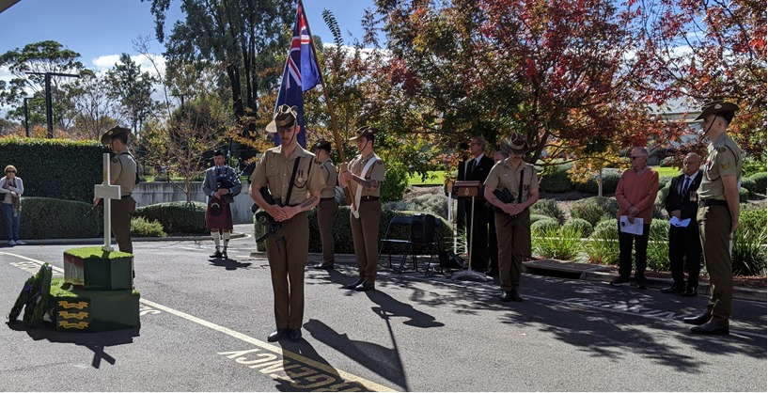

7RAR Catafalque Party under the command of Cpl Webb at the RARA-SA (Burnside) RSL’s Regis Aged Care (Linden Park) ANZAC Service, Wednesday 24th April, 2024. RARA-SA Member Gino Arendic shown is reciting “Prayer of Remembrance” with Piper Andrew Leahy from the City Of Adelaide Pipe Band on the left rea and members Derek Freeman and Colin Abel on the right. The Annual Service was very much appreciated by the 100 plus residents and staff in attendance. Sincere appreciation to all involved especially Lt Colonel Levon “von” Lambert, 2IC Major Rupert Hindle, RSM WO1 Allan Ashman and all members of 7RAR.

**2024 ANZAC Day Commemorative March, Adelaide**

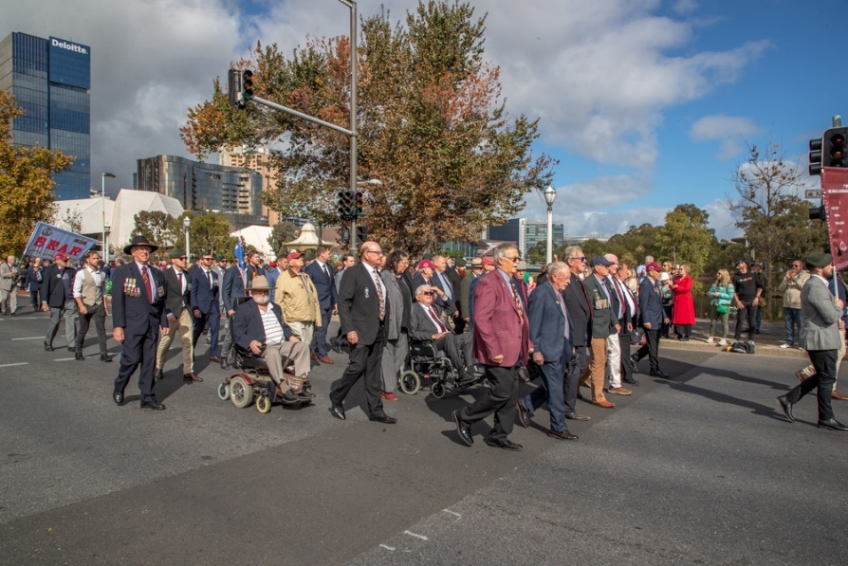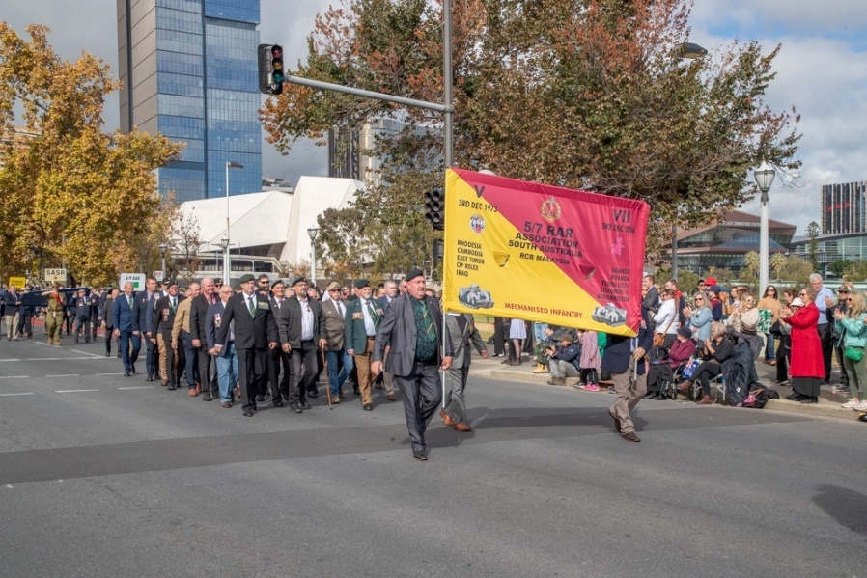

(Photographs courtesy of RSL-SA)

Left 7 RARA-SA and Right 5/7 RARA-SA on King William Road, Adelaide

Thanks to RARA-SA Commemorations Officer Adrian Craig supported by all Battalion representatives for all their “hard yakka” in another successful ANZAC Day March. Additionally to all those who marched. Also to Colin Abel for again dropping off the Battalion banners from the RARA-SA and collecting them afterwards for their safe return there.

Colin was also the MC at the RARA-SA (Burnside) RSL’s ANZAC Day Dawn Service at Linden Park where local Beatty Street residents were awakened to the skirl of Piper Tim Leahy from the City of Adelaide Pipe Band “Piping in the Dawn” ahead of the Service.

RARA-SA See the source image Club Manager / RARA-SA (Burnside) RSL Image result for rsl logos Sub Branch Secretary M: 0412 644 749 / E: [rar01@internode.on.net](mailto:rar01@internode.on.net) / W:  [www.rarasa.org.au](http://www.rarasa.org.au) / Facebook [RAR SA](https://www.facebook.com/RAR-SA-Community-107486164360599) – “***Duty First”***

**Proudly Supported By Bolton Clarke** Image result for bolton clarke logoImage result for bolton clarke logoImage result for bolton clarke logo **Australia’s Largest Independent Private Aged Care Provider**