Patron: Colonel Steve Larkins OAM (Ret’d) President: Michael von Berg MC OAM

From the RARA-SA – Week Ending Friday 19th April, 2024

Fridays From 1600hrs to 2100hrs At 13 Beatty Street, Linden Park

[www.rarasa.org.au](http://www.rarasa.org.au) refers for all news and information

**This Friday 19th April, 2024 - Featuring Andrew Faulkner’s Book Launch**

1600hrs - Traditional Evening Camaraderie over Evening drinks, in addition to tea and coffee being available, bar snacks

from 1700hrs with appreciation to WO2 Caterer Colin Abel, followed at 1800hrs by the *Stand Fast*

incorporating the reciting of *the Ode* and the *Traditional Refrains*.

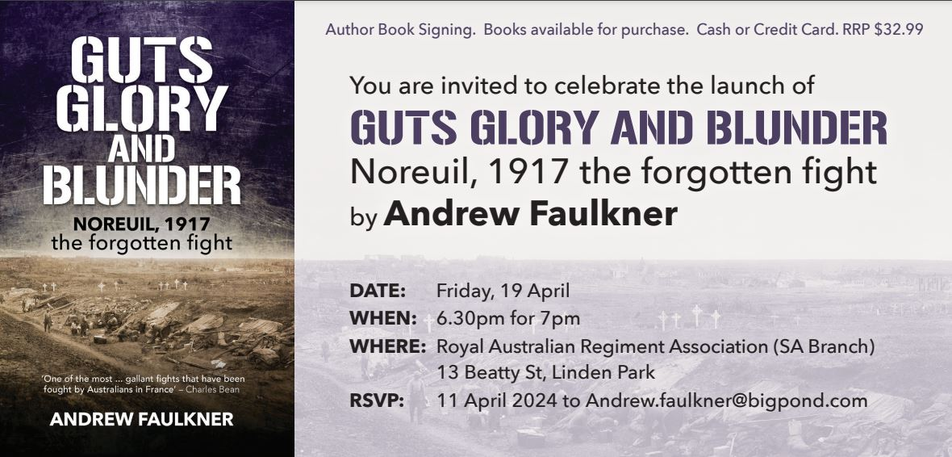

**No Committee Meeting for this month.**

**Kapyong Day Luncheon**

The attached screed refers to this year’s Kapyong Day luncheon, 1200hrs on Wednesday 24th April, 2024 at the Lord Melbourne Hotel, 63 Melbourne Street, North Adelaide. RSVP 3 RARA-SA’s President Jeff Barratt on SMS to 0451 265 269 or email: [gadgetbarrett@gmail.com](mailto:gadgetbarrett@gmail.com) Due to the “ravages of age”, the RARA-SA will unfortunately not be conducting a Kapyong Day Service at the RARA-SA this year. Kapyong Day has now come to represent all who served in the Korean War.

**ANZAC Rosemary Appeal – Friday 19th April to Wednesday 24th April, 2024**

We are conducting this year’s ANZAC Rosemary Appeal at the Walkerville Shopping Centre, Walkerville Terrace, Walkerville (courtesy of the owners the Region Group and Shopping Centre management, Knight Frank) and at the North Adelaide Shopping Centre (courtesy of the owners and Shopping Centre Management, GBRE). Also sincere appreciation to 7 RAR’s CO, Lt Colonel Levon “von” Lambert, 2IC Major Rupert Hindle, RSM WO1 Al Ashman and all ranks for their support in addition to the surrounding populace for their support. Volounteers are required for this Saturday 20th and Sunday 21st April. Contact Mal Allen M: 0451 374 133 / E: [mal@aladdco.com.au](mailto:mal@aladdco.com.au)

[Image result for rosemary images on anzac
                      day](https://urldefense.com/v3/__https:/www.bing.com/images/search?view=detailV2&ccid=qH1ankBY&id=9FEF2C1D6AE243334299123152D3DBD14A718CB5&thid=OIP.qH1ankBYGV83zQbWZn1v_wHaEG&mediaurl=http*3a*2f*2f1.bp.blogspot.com*2f-N7M1h7baDyg*2fT5ewxdWP-KI*2fAAAAAAAAAbE*2fLYgqyjVpaio*2fs1600*2fAnzac*2bDay*2bwith*2brosemary*2bfor*2bremembrance*255B1*255D.gif&exph=155&expw=280&q=rosemary*images*on*anzac*day&simid=608030305981366795&selectedIndex=0__;JSUlJSUlJSUlJSUlJSUlJSsrKys!!NFWRZ6kECLqu!-fz6s7CFuoBXTBWvZySlV8npYL8uw3sIbnWo14e2MBauKm28iVrIeKBYmRZAsG4voKN1$)

**ANZAC Service**

Wednesday 23rd. April, 2024 - 1100hrs Regis Aged Care, 6 Booth Ave, Linden Park Contact Mal Allen M: 0451 374 133 /

**ANZAC Day** See the source image**Dawn Services involving the RARA-SA and RARA-SA (Burnside) RSL**

RARA-SA Clubrooms - 13 Beatty Street, Linden Park – Contact Colin Abel E: [kcabel@bigpond.com](mailto:kcabel@bigpond.com)

Norwood War Memorial – Osmond Tce / The Parade, Norwood – Contact Mal Allen – E: [mal@aladdco.com.au](mailto:mal@aladdco.com.au)

Rose Park War Memorial – Prescott Tce – Contact Colonel (Ret’d) Steve Larkins OAM [sandglarkins@outlook.com](mailto:sandglarkins@outlook.com)

Kensington Park RSL War Memorial - 342 The Parade, Norwood – Contact Rod Graham E: [rodg2@bigpond.com](mailto:rodg2@bigpond.com)

LIVGolf ANZAC Arvo Service – Grange Golf Club - Two Up School Demonstration – Mal Allen E: [mal@aladdco.com.au](mailto:mal@aladdco.com.au)

Many thanks to all RARA-SA incorporating the RARA-SA (Burnside) personnel involved, in addition to 7 RAR’s CO Lt Colonel Levon “von” Lambert for the provision of 7 RAR personnel, Tim from AllPro Communications for his sound equipment, Pipers from the City of Adelaide Pipe Band and the singers, buglers and community organisations support.

The Adelaide ANZAC RSL-SA Guide 2024 can be viewed at <https://bit.ly/4cMtDi3> Order of March, Assembly Areas, Route Map, Dispersals. Extensive Anzac Information [https://bit.ly/3IZaFXu](https://l.facebook.com/l.php?u=https%3A%2F%2Fbit.ly%2F3IZaFXu%3Ffbclid%3DIwAR1JNdAOvBDcdG8zWieh7Wkw075JbpZoSDf8Fbp2bgNAoth-eoo5nIuuRdM_aem_AWrlW4hffcPMUIOv26lRgTEkzBsrtbnGIAcr00AbZTDS1bCsSDi_suQRlC7K4FNuxbMg-YAwuwxuZj2j_zTdu02v&h=AT0X5_xPjfvy9wxFEpilcMrhrYRbZkgFj9cnSnFQCKI2IaOSsEqLMKFcgT1K_9bYvJe26t2Q-I1dTclJlxWuQOXwZrrB2NbJtc-uO3XceyzSLHZDB_M6JnR7GRmhd1lUAYvx&__tn__=-UK-R&c%5b0%5d=AT1evc6kR3ZMcFA-ZGEIly-TBk2ojytcTFZPf2vb1loKYl0smxteaXRSDsZIHIZuVJOViTy_WxGJvjcE9Sl6IGvC9ydzuuaJf4eW3boHSq70CyfD1hoaCAmM4TEOLLz1tvh-XXFNrf2wmmbRdM2uS_gw4cn41ukTxYpI3RNBIMyPujeWVQ)

[#RSLSouthAustralia](https://www.facebook.com/hashtag/rslsouthaustralia?__eep__=6&__cft__%5b0%5d=AZVBnEVdmjkXJvFjfQi08vVNriZBRN_wbV6ABg1VSkGkBnQLSI5UC4XhS83vC5GLameg5DDnYIYXUmxAQt3HzhKj0f3bV8gkQkIY3yMF3FusnpswYUQjGaxTBQE2hj_w1I9a9OB5EoJDZlZTHPoP8hyg&__tn__=*NK-R) [#RSLAustralia](https://www.facebook.com/hashtag/rslaustralia?__eep__=6&__cft__%5b0%5d=AZVBnEVdmjkXJvFjfQi08vVNriZBRN_wbV6ABg1VSkGkBnQLSI5UC4XhS83vC5GLameg5DDnYIYXUmxAQt3HzhKj0f3bV8gkQkIY3yMF3FusnpswYUQjGaxTBQE2hj_w1I9a9OB5EoJDZlZTHPoP8hyg&__tn__=*NK-R) [#anzacday2024](https://www.facebook.com/hashtag/anzacday2024?__eep__=6&__cft__%5b0%5d=AZVBnEVdmjkXJvFjfQi08vVNriZBRN_wbV6ABg1VSkGkBnQLSI5UC4XhS83vC5GLameg5DDnYIYXUmxAQt3HzhKj0f3bV8gkQkIY3yMF3FusnpswYUQjGaxTBQE2hj_w1I9a9OB5EoJDZlZTHPoP8hyg&__tn__=*NK-R) [#adelaide](https://www.facebook.com/hashtag/adelaide?__eep__=6&__cft__%5b0%5d=AZVBnEVdmjkXJvFjfQi08vVNriZBRN_wbV6ABg1VSkGkBnQLSI5UC4XhS83vC5GLameg5DDnYIYXUmxAQt3HzhKj0f3bV8gkQkIY3yMF3FusnpswYUQjGaxTBQE2hj_w1I9a9OB5EoJDZlZTHPoP8hyg&__tn__=*NK-R)

RARA-SA March contact – Adrian Craig E: [as.craig9rar@bigpond.com](mailto:as.craig9rar@bigpond.com)

**ANZAC Day** See the source image**Reunion** – from 1130hrs - Lion Hotel cnr Melbourne and Jerningham Streets, North Adelaide.

**Veterans SA - Community Connection event**

Registrations are open for our next Community Connection on Tuesday 30 April. This is a great event for organisations that deliver services or support to veterans, or anyone wanting to learn more about veteran employment and support

services in SA. [REGISTER NOW >](https://defencesa.us12.list-manage.com/track/click?u=23d20d4049d9938e1bc6c78d1&id=e680caa053&e=517f9fb07b)

**On This Day – Information Courtesy of the AWM**

27th. February to 15th. April, 1968 – Operation Pinnaroo – Long Hai Hills, South Vietnam – A combined operation by 2RAR/NZ (ANZAC) and 3RAR which involved for the first time Centurian Battle Tanks from C Squadron, 1st Armoured Regiment. A long arduous and extremely dangerous operation and a credit to all personnel involved. Extract from Military Author and Historian Lt Colonel Fred Fairhead’s “A Duty Done”.

12th April, 1918 - Battle of Hazebrouck, Western Front WW1 - Hazebrouck, a crucial rail centre, 30 kilometres west of Armentieres, was threatened by the German offensive on the Lys. The 1st Australian Division repelled several heavy German attacks.

12th April, 1941 - ANZAC Corps reformed in Greece by General Blamey. Australian and New Zealand troops fought alongside soldiers from Greece and Britain in the ill-fated Greek campaign. Blamey, however, conducted a skillful evacuation of the ANZAC Corps from southern Greece at the end of the campaign.

13th April, 1916 – Jifjaffa WW1 - A squadron of the 9th Light Horse Regiment captured this Turkish outpost in the Sinai, about 60 kilometres from the Suez. The encounter, the first engagement for the Light Horse in the Sinai, demonstrated their potential for fighting in the Middle East.

13th April, 1941 – Middle East WW11 - Corporal J.H. Edmondson, VC, 2/17th Battalion, AIF, originally from Wagga Wagga, NSW, was awarded the Victoria Cross for his actions on this day at Tobruk. It was a posthumous award.

RARA-SA See the source image Club Manager / RARA-SA (Burnside) RSL Image result for rsl logos Sub Branch Secretary M: 0412 644 749 / E: [rar01@internode.on.net](mailto:rar01@internode.on.net) / W:  [www.rarasa.org.au](http://www.rarasa.org.au) / Facebook [RAR SA](https://www.facebook.com/RAR-SA-Community-107486164360599) – “***Duty First”***

**Proudly Supported By Bolton Clarke** Image result for bolton clarke logoImage result for bolton clarke logoImage result for bolton clarke logo **Australia’s Largest Independent Private Aged Care Provider**