Patron: Colonel Steve Larkins OAM (Ret’d) President: Michael von Berg MC OAM

From the RARA-SA – ANZAC Week Ending Friday 26th April, 2024

Fridays From 1600hrs to 2100hrs At 13 Beatty Street, Linden Park

[www.rarasa.org.au](http://www.rarasa.org.au) refers for all news and information

[Image result for rosemary images on anzac
                      day](https://urldefense.com/v3/__https:/www.bing.com/images/search?view=detailV2&ccid=qH1ankBY&id=9FEF2C1D6AE243334299123152D3DBD14A718CB5&thid=OIP.qH1ankBYGV83zQbWZn1v_wHaEG&mediaurl=http*3a*2f*2f1.bp.blogspot.com*2f-N7M1h7baDyg*2fT5ewxdWP-KI*2fAAAAAAAAAbE*2fLYgqyjVpaio*2fs1600*2fAnzac*2bDay*2bwith*2brosemary*2bfor*2bremembrance*255B1*255D.gif&exph=155&expw=280&q=rosemary*images*on*anzac*day&simid=608030305981366795&selectedIndex=0__;JSUlJSUlJSUlJSUlJSUlJSsrKys!!NFWRZ6kECLqu!-fz6s7CFuoBXTBWvZySlV8npYL8uw3sIbnWo14e2MBauKm28iVrIeKBYmRZAsG4voKN1$)

**Thursday 25th April, 2024**

**Traditional ANZAC Day flora - Wild Rosemary See
                  the source imagefrom the Clifftops of Gallipoli**

**Rosemary See
                  the source imagebeing the traditional emblem for Fidelity and Remembrance.**

**The wearing of a sprig of Rosemary See
                  the source imageon ANZAC Day acknowledges this.**

**ANZAC Day Commemorative March – Adelaide, 2024 – “March With A Mate”**

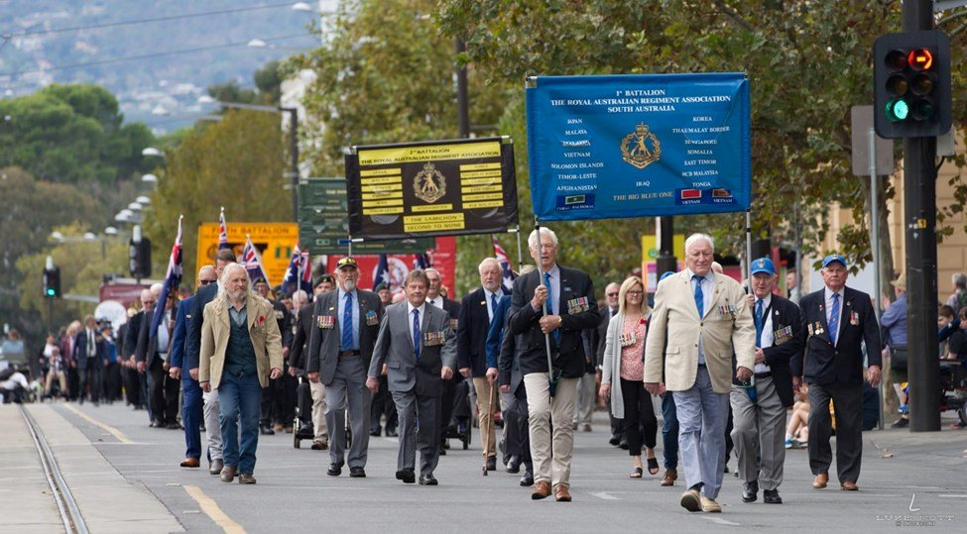

(Last year’s March is featured above)

On North Terrace by the Pulteney Street corner – The RARA-SA has now moved up to Group 7 - Battalion Banners to be collected by 0815hrs at the Form Up area - Form Up by 0915hrs – Step Off approximately 0930

The Adelaide ANZAC RSL-SA Guide 2024 can be viewed at <https://bit.ly/4cMtDi3> Order of March, Assembly Areas, Route Map, Dispersals. Extensive Anzac Information [https://bit.ly/3IZaFXu](https://l.facebook.com/l.php?u=https%3A%2F%2Fbit.ly%2F3IZaFXu%3Ffbclid%3DIwAR1JNdAOvBDcdG8zWieh7Wkw075JbpZoSDf8Fbp2bgNAoth-eoo5nIuuRdM_aem_AWrlW4hffcPMUIOv26lRgTEkzBsrtbnGIAcr00AbZTDS1bCsSDi_suQRlC7K4FNuxbMg-YAwuwxuZj2j_zTdu02v&h=AT0X5_xPjfvy9wxFEpilcMrhrYRbZkgFj9cnSnFQCKI2IaOSsEqLMKFcgT1K_9bYvJe26t2Q-I1dTclJlxWuQOXwZrrB2NbJtc-uO3XceyzSLHZDB_M6JnR7GRmhd1lUAYvx&__tn__=-UK-R&c%5b0%5d=AT1evc6kR3ZMcFA-ZGEIly-TBk2ojytcTFZPf2vb1loKYl0smxteaXRSDsZIHIZuVJOViTy_WxGJvjcE9Sl6IGvC9ydzuuaJf4eW3boHSq70CyfD1hoaCAmM4TEOLLz1tvh-XXFNrf2wmmbRdM2uS_gw4cn41ukTxYpI3RNBIMyPujeWVQ)

[#RSLSouthAustralia](https://www.facebook.com/hashtag/rslsouthaustralia?__eep__=6&__cft__%5b0%5d=AZVBnEVdmjkXJvFjfQi08vVNriZBRN_wbV6ABg1VSkGkBnQLSI5UC4XhS83vC5GLameg5DDnYIYXUmxAQt3HzhKj0f3bV8gkQkIY3yMF3FusnpswYUQjGaxTBQE2hj_w1I9a9OB5EoJDZlZTHPoP8hyg&__tn__=*NK-R) [#RSLAustralia](https://www.facebook.com/hashtag/rslaustralia?__eep__=6&__cft__%5b0%5d=AZVBnEVdmjkXJvFjfQi08vVNriZBRN_wbV6ABg1VSkGkBnQLSI5UC4XhS83vC5GLameg5DDnYIYXUmxAQt3HzhKj0f3bV8gkQkIY3yMF3FusnpswYUQjGaxTBQE2hj_w1I9a9OB5EoJDZlZTHPoP8hyg&__tn__=*NK-R) [#anzacday2024](https://www.facebook.com/hashtag/anzacday2024?__eep__=6&__cft__%5b0%5d=AZVBnEVdmjkXJvFjfQi08vVNriZBRN_wbV6ABg1VSkGkBnQLSI5UC4XhS83vC5GLameg5DDnYIYXUmxAQt3HzhKj0f3bV8gkQkIY3yMF3FusnpswYUQjGaxTBQE2hj_w1I9a9OB5EoJDZlZTHPoP8hyg&__tn__=*NK-R) [#adelaide](https://www.facebook.com/hashtag/adelaide?__eep__=6&__cft__%5b0%5d=AZVBnEVdmjkXJvFjfQi08vVNriZBRN_wbV6ABg1VSkGkBnQLSI5UC4XhS83vC5GLameg5DDnYIYXUmxAQt3HzhKj0f3bV8gkQkIY3yMF3FusnpswYUQjGaxTBQE2hj_w1I9a9OB5EoJDZlZTHPoP8hyg&__tn__=*NK-R)

RARA-SA March contact – Adrian Craig E: [as.craig9rar@bigpond.com](mailto:as.craig9rar@bigpond.com)

**Kapyong Day Luncheon**

This year’s Kapyong Day luncheon will be held 1200hrs tomorrow Wednesday 24th April, 2024 at the Lord Melbourne Hotel, 63 Melbourne Street, North Adelaide. RSVP 3 RARA-SA’s President Jeff Barrett on SMS to 0451 265 269 or email: [gadgetbarrett@gmail.com](mailto:gadgetbarrett@gmail.com) Due to the “ravages of time”, the RARA-SA will unfortunately not be conducting a Kapyong Day Service at the RARA-SA this year. Kapyong Day has now come to represent all who served in the Korean War.

**ANZAC** See the source image**Service**

Wednesday 24th April, 2024 - 1100hrs Regis Aged Care, 6 Booth Ave, Linden Park Contact Mal Allen M: 0451 374 133

**ANZAC Day** See the source image**Dawn Services involving the RARA-SA and RARA-SA (Burnside) RSL**

RARA-SA Clubrooms - 13 Beatty Street, Linden Park – Contact Colin Abel E: [kcabel@bigpond.com](mailto:kcabel@bigpond.com)

Norwood War Memorial – Osmond Tce / The Parade, Norwood – Contact Mal Allen – E: [mal@aladdco.com.au](mailto:mal@aladdco.com.au)

Rose Park War Memorial – Prescott Tce – Contact Colonel (Ret’d) Steve Larkins OAM [sandglarkins@outlook.com](mailto:sandglarkins@outlook.com)

Kensington Park RSL War Memorial - 342 The Parade, Norwood – Contact Rod Graham E: [rodg2@bigpond.com](mailto:rodg2@bigpond.com)

LIVGolf ANZAC Arvo Service – Grange Golf Club - Two Up School Demonstration – Mal Allen E: [mal@aladdco.com.au](mailto:mal@aladdco.com.au)

Many thanks to all RARA-SA incorporating the RARA-SA (Burnside) RSL personnel involved, in addition to 7 RAR’s CO Lt Colonel Levon “von” Lambert for the provision of 7 RAR personnel, Tim from AllPro Communications for his sound equipment, Pipers from the City of Adelaide Pipe Band and the singers, buglers and community organisations support.

**ANZAC Day** See the source image**Reunion** – from 1130hrs - Lion Hotel cnr Melbourne and Jerningham Streets, North Adelaide.

**ANZAC Rosemary Appeal – Friday 19th April to Wednesday 24th April, 2024**

With appreciation to 7RAR’s CO, Lt Colonel Levon “von” Lambert, 2IC Major Rupert Hindle, RSM WO1 Al Ashman and all ranks for their excellent support; in addition to the Shopping Centres’ management and surrounding populace

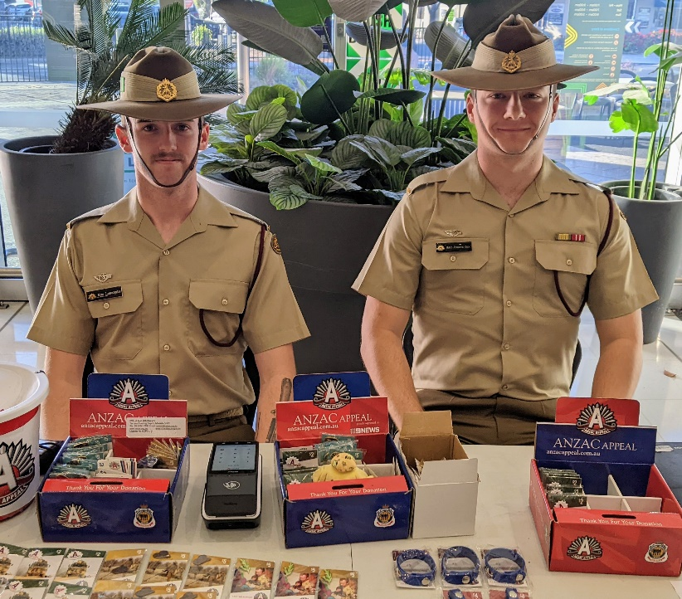

Left - L to R: Kyle Luscombe and Mark “JJ” Jovanovic – Walkerville Shopping Centre

Right - L to R: Danelo Arigore and Jared McLachlan – North Adelaide Shopping Village

**Last Friday 19th April, 2024 - Featuring Andrew Faulkner’s Book Launch**

**by Patron Colonel Steven Larkins OAM**

**Guts, Glory and Bunder – Noreuil 1917 – The Forgotten Fight**

A great evening with approximately 90 odd attending. Special thanks to Andrew Faulkner (author, WO2 Caterer Colin Abel and Club Manager Greg “Spike” Dwiar assisted by Vice President Rod Graham and Maria Capriulo.

A full report and photographic collage next week.

RARA-SA See the source image Club Manager / RARA-SA (Burnside) RSL Image result for rsl logos Sub Branch Secretary M: 0412 644 749 / E: [rar01@internode.on.net](mailto:rar01@internode.on.net) / W:  [www.rarasa.org.au](http://www.rarasa.org.au) / Facebook [RAR SA](https://www.facebook.com/RAR-SA-Community-107486164360599) – “***Duty First”***

**Proudly Supported By Bolton Clarke** Image result for bolton clarke logoImage result for bolton clarke logoImage result for bolton clarke logo **Australia’s Largest Independent Private Aged Care Provider**